The Usecase to hack, Your Challenge! – ING Product Application

Build the following two screens including the flow between them. With this you can get insight in ING products and some details on them. Next to that have monitoring in place (screen 3) on the usage of the screens and selected products

**Screen1: Overview ING product groups**

**Build a backend solution to make the following info available for the front-end**

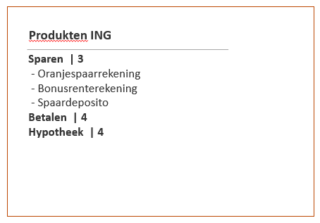

**Source for above screen:**

|  |  |  |  |  |  |
| --- | --- | --- | --- | --- | --- |
|  |  |  |  |  |  |
| *Produktgroep* | *Product group* | *Produktnaam* | *Product name* |  |  |
| Hypotheek | Mortgage | Bankspaarhypotheek | Bank saving mortgage |  |  |
|  |  | Aflossingsvrij | Interest-only |  |  |
|  |  | Annuiteit | Annuity |  |  |
|  |  | Lineair | Linear |  |  |
| Betalen | Payments | Betaalrekening | Payments account |  |  |
|  |  | Betaalpas | Debit card |  |  |
|  |  | Kwartaallimiet | Quarterly limit |  |  |
|  |  | Continu limiet | Continuously limit |  |  |
| Sparen | Savings | Oranjespaarrekening | Orange savings account |  |  |
|  |  | Groeigroterrekening | Child savings account |  |  |
|  |  | Spaarrekening voor Unicef | Savings account for Unicef |  |  |
|  |  | Bonusrenterekening | Bonus interest account |  |  |
|  |  | Spaardeposito | Savings deposit |  |  |
|  |  | Groen Spaardeposto | Green savings deposit |  |  |
| Lenen | Loans | Doorlopend krediet | Revolving credit |  |  |
|  |  | Persoonlijke Lening | Personal loan |  |  |
|  |  | Lening voor auto | Car loan |  |  |
|  |  | Lening voor verbouwing | Renovation loan |  |  |
| Creditcard | Credit card | Creditcard | Credit card |  |  |
|  |  | Platinumcard | Platinum card |  |  |
|  |  | Studenten Creditcard | Student card |  |  |

**Screen2:**

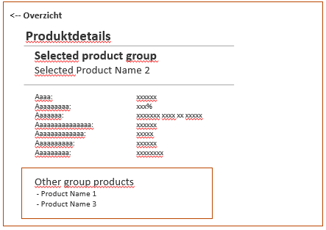

**Screen3: Monitoring**

